Internship Project Report

1. INTRODUCTION
1.1 Project Overview
This initiative centers around utilizing Tableau to conduct data analysis on the Toy Craft dataset — a retail-focused dataset encompassing product sales, stock levels, and customer demographic details. The objective is to uncover trends and generate insightful visual representations that facilitate informed, data-based decision-making..

1.2 Purpose
- Explore Tableau as an effective tool for data visualization and business intelligence.
- Analyze Toy Craft’s sales data, customer behavior patterns, and product performance metrics.
- Extract actionable insights and present findings through interactive, user-friendly dashboards.

2. IDEATION PHASE
2.1 Problem Statement
What is a Customer Problem Statement?
Understand Your Customer's Struggle
Before solving a problem, walk in your customer's shoes. This template helps you uncover their needs, frustrations, and emotions.
Why Use It?
The Super Simple Format I am [who the customer is]
I'm trying to [what they want to do]
But [what's stopping them?]
Because [why is this a problem?]
Which makes me feel [how do they feel?]
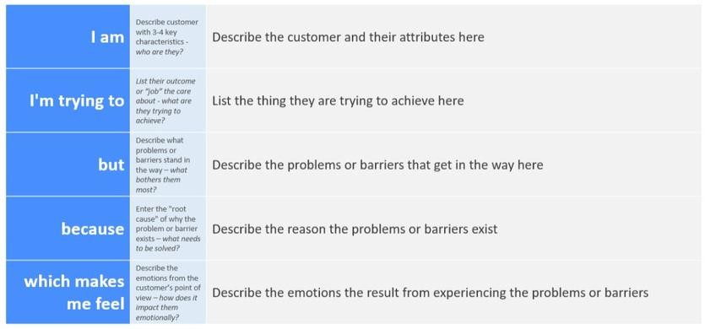
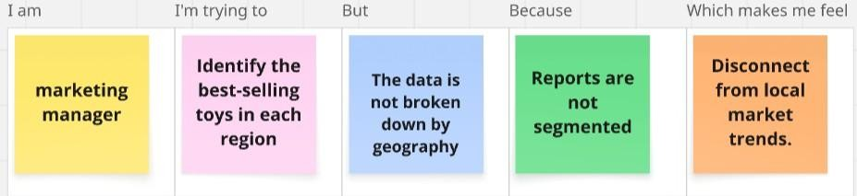
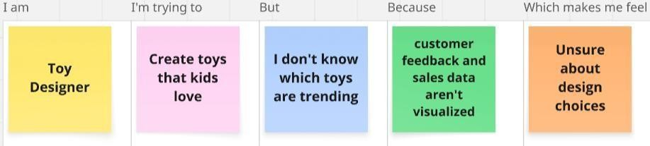
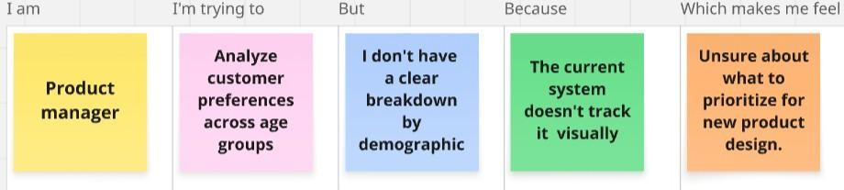
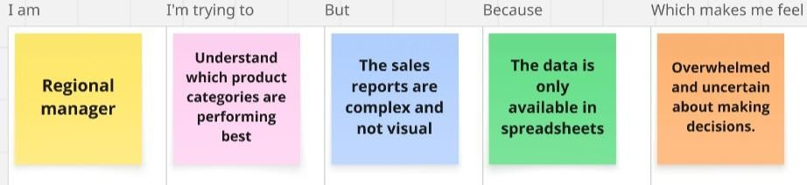

Problem  Statement(PS) | I am  (Customer) | I’m trying to | But | Because | Which makes me  feel
PS-1 | Marketing Manager | Identify the bestselling toys in each region | The data is not broken down by geography | Reports are not segmented | Disconnect from the local market trends.
PS-2 | Regional Manager | Understand which product categories best | The sales reports are complex and not visual | The data is only available in spreadsheets | Overwhelmed and uncertain about making decisions.
PS-3 | Toy Designer | Create toys that kids love | I don’t know which toys are trending | Customer feedback, sales data aren’t good | Unsure about design choices
PS-4 | Product Manager | Analyse customer needs according to age | I don’t have a clear breakdown by demographic | The current system doesn’t  track it visually | Unsure about what to prioritize for new product design.

2.2 Empathy Map Canvas
In today’s data-driven landscape, possessing data alone is not sufficient — the real value lies in understanding the people behind the numbers: their challenges, needs, and goals. Our project, "ToyCraft Tales: Tableau's Vision into Toy Manufacturer Data," focuses on transforming complex toy sales data into meaningful, actionable insights through powerful visualizations.
To do this effectively, we first needed to understand our users — the toy manufacturers, analysts, and decision-makers — not just as stakeholders, but as individuals. The “Empathy Map Canvas” served as a crucial tool in this process, allowing us to explore what they see, hear, think, and feel in their daily roles.
We discovered that behind every delayed report or inventory misstep is a person doing their best with limited resources. What they truly seek is clarity, efficiency, and control — and it became our mission to deliver just that through intuitive, insightful dashboards.

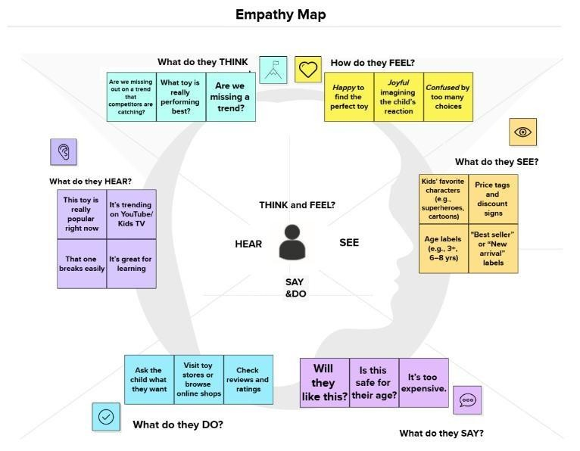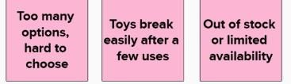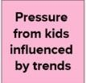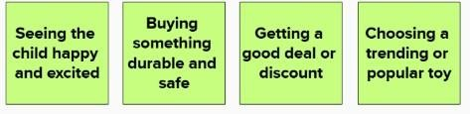

2.3 Brainstorming
Brainstorming provides a free and open environment that encourages everyone within a team to participate in the creative thinking process that leads to problem solving. Prioritizing volume over value, out-of-the-box ideas are welcome and built upon, and all participants are encouraged to collaborate, helping each other develop a rich amount of creative solutions.
Use this template in your own brainstorming sessions so your team can unleash their
imagination and start shaping concepts even if you're not sitting in the same room. In this project, our team of five data analysts set out to explore how distribution processes and customer behavior impact toy success—from manufacturing to customer delivery—using Tableau dashboards.
We focused on two key questions:
- How do delivery times and shipping partners affect customer satisfaction and product returns?
- What patterns in customer preferences and order frequency reveal actionable trends for demand planning?
The dataset included details like shipping duration, partner performance ratings, return frequencies, order channels (e.g., online, retail), and product review data. We began with a brainstorming session where each member shared ideas. We then grouped and prioritized them based on complexity, effort, and impact. This helped us focus on the most valuable insights and assign tasks based on team strengths. The outcome: a set of clear, interactive dashboards that visualize ToyCraft’s distribution and customer experience journey—empowering business teams to make
smarter, logistics-informed decisions.
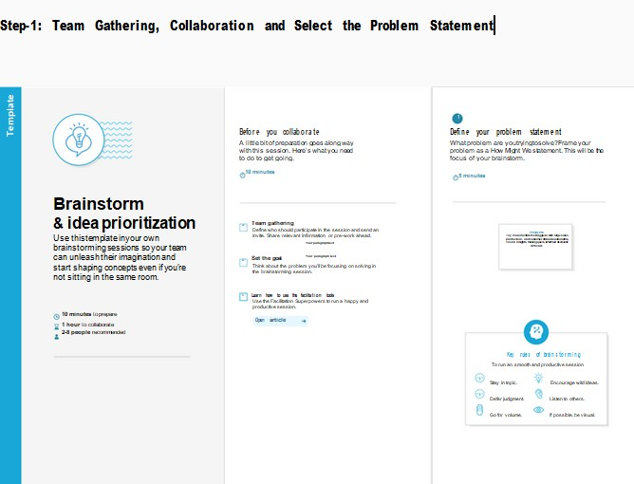

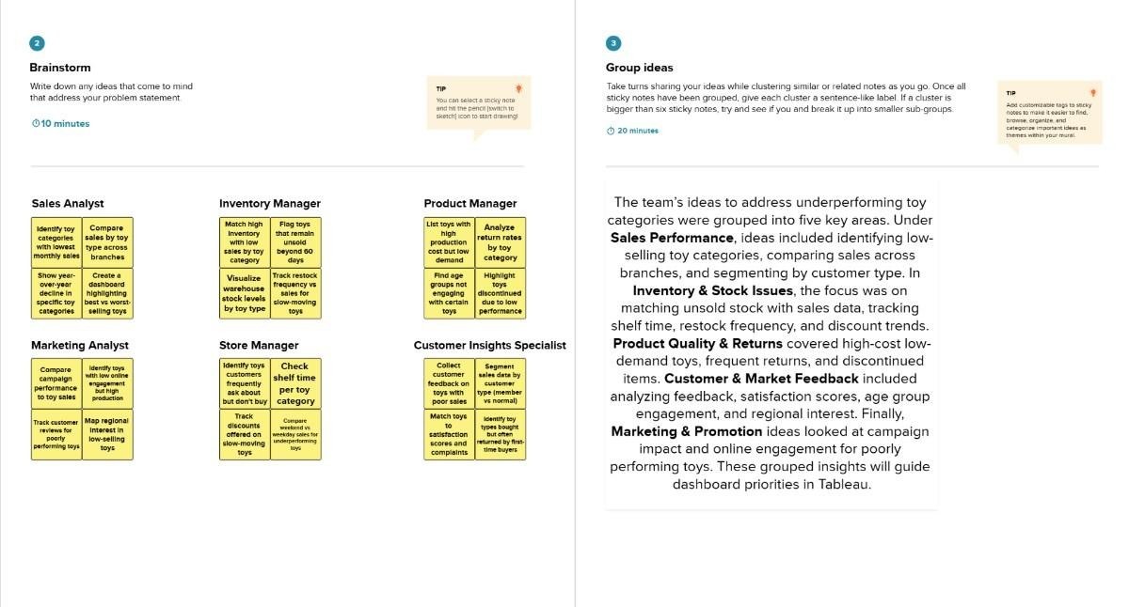
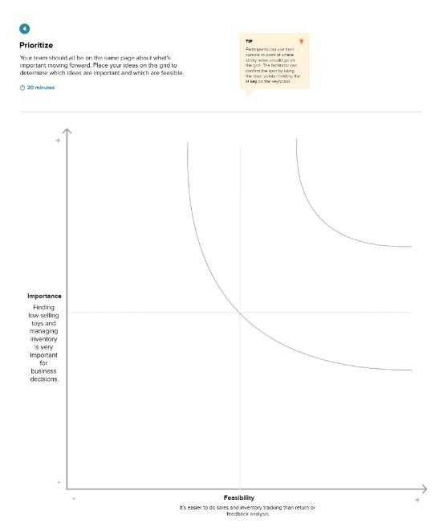

3. REQUIREMENT ANALYSIS
3.1 Customer Journey Map
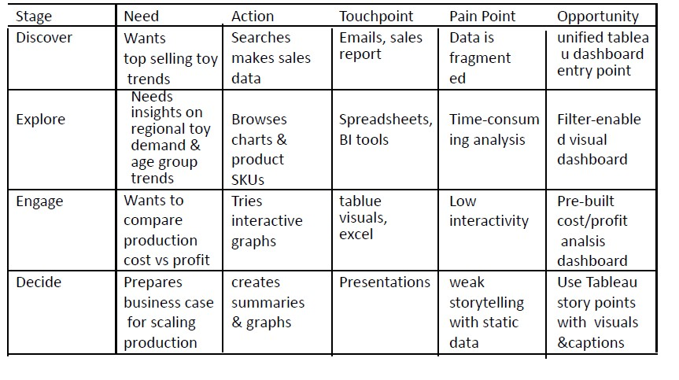

3.2 Solution Requirement
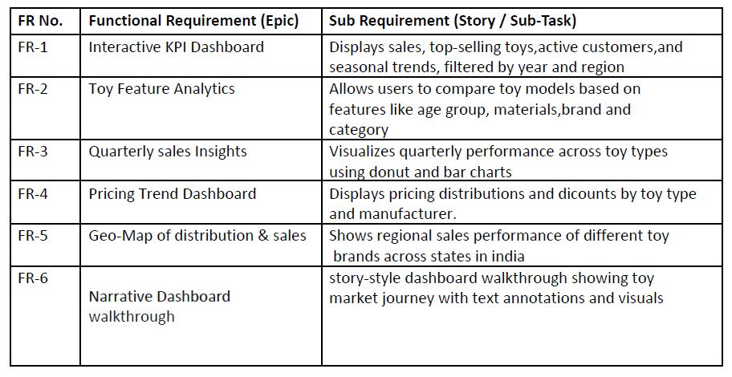

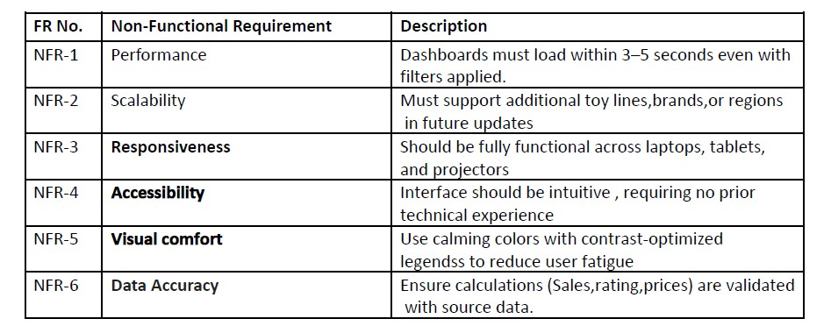

3.3 Data Flow Diagram Data Flow Diagrams:
A Data Flow Diagram (DFD) is a structured graphical method used in system analysis and information systems design. It illustrates external entities interacting with the system, the flow of data, internal processes, and data storage components. DFDs help visualize how different parts of a system relate to one another and are commonly used in both business analysis and IT system modeling.
DFDs are particularly effective for representing high-level system details, showing how input data is transformed into output through a sequence of functional processes. There are two primary notations used in DFDs: Yourdon and Gane-Sarson, which differ mainly in their graphical syntax.
An example of a DFD for an Online Store demonstrates interactions between key entities such as Customers, Visitors, and Sellers. It includes components like User Databases and details the flow of Website Information. Tools like ConceptDraw DIAGRAM, enhanced with the Data Flow Diagrams solution, provide dedicated libraries of standardized DFD symbols, making it easy to create clear and professional diagrams for online stores and other systems.

3.4 Technology Stack
Technical Architecture:
"ToyCraft Tales: Tableau’s Window into Toy Manufacturer Analytics"
Example: Data-Driven Business Intelligence System for a Toy Manufacturer Using Tableau Scenario:
A toy manufacturing company aims to gain real-time visibility into key operational metrics such as production efficiency, inventory turnover, and sales performance. To achieve this, the organization deploys a data-driven BI system powered by Tableau, integrating information from core business systems including ERP (Enterprise Resource Planning), CRM (Customer Relationship Management), and SCM (Supply Chain Management) platforms.
This architecture enables seamless data ingestion and consolidation across disparate sources, allowing for dynamic, interactive dashboards that present actionable insights to managers, analysts, and decision-makers.
System Capabilities:
- Production Efficiency Monitoring: Track throughput, downtime, and operational KPIs to optimize manufacturing workflows.
- Inventory Turnover Analysis: Evaluate stock movement and warehouse utilization to reduce holding costs and avoid overstock or stockouts.
- Sales Performance Tracking: Visualize regional sales trends, product performance, and customer behavior to drive strategic growth.
Architecture Highlights:
- Data Integration Layer: Aggregates structured data from ERP, CRM, and SCM systems.
- Data Processing Engine: Performs cleansing, transformation, and enrichment tasks to ensure consistency and quality.
- Visualization Layer (Tableau): Presents real-time dashboards and reports, enabling business users to explore data with minimal technical expertise.
- Security and Governance: Ensures secure access, user role management, and compliance with data governance policies.
Inspired by IBM’s AI-powered backend system patterns, this architecture emphasizes modularity, real-time analytics, and scalable integration—empowering the toy manufacturer to make faster, data-informed decisions in a dynamic market environment.

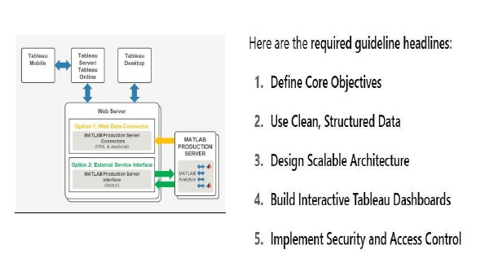
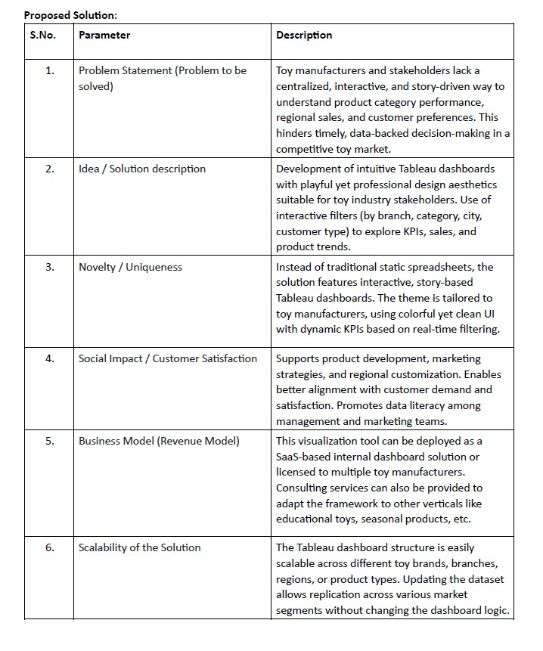

References:
- IBM Architecture Reference: https://developer.ibm.com/patterns/online-orderprocessing-system-during-pandemic/
- C4 Architecture: https://c4model.com/
- AWS Architecture: https://aws.amazon.com/architecture

4. PROJECT DESIGN
4.1 Problem Solution Fit

Problem – Solution Fit Template:

The Problem-Solution Fit simply means that you have found a problem with your customer and that the solution you have realized for it actually solves the customer’s problem. It helps entrepreneurs, marketers and corporate innovators identify behavioral patterns and recognize what would work and why Purpose:
❑ Solve complex problems in a way that fits the state of your customers.
❑ Succeed faster and increase your solution adoption by tapping into existing mediums and channels of behavior.
❑ Sharpen your communication and marketing strategy with the right triggers and messaging.
❑ Increase touch-points with your company by finding the right problem-behavior fit and building trust by solving frequent annoyances, or urgent or costly problems.
❑ Understand the existing situation in order to improve it for your target group.
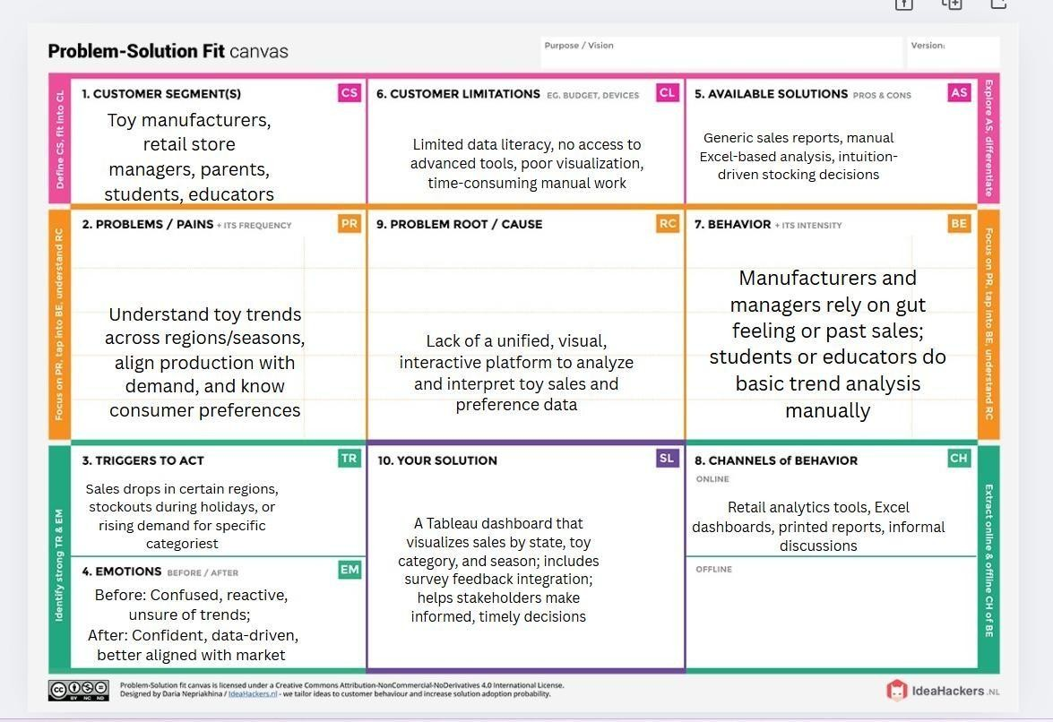
References:
- https://www.ideahackers.network/problem-solution-fit-canvas/
- https://medium.com/@epicantus/problem-solution-fit-canvas-aa3dd59cb4fe

  - Proposed Solution
S.No. | Parameter | Description
1. | Problem Statement (Problem to be solved) | Toy manufacturers and stakeholders lack a centralized, interactive, and story-driven way to understand product category performance, regional sales, and customer preferences. This hinders timely, data-backed decision-making in a competitive toy market.
2. | Idea / Solution description | Development of intuitive Tableau dashboards with playful yet professional design aesthetics suitable for toy industry stakeholders. Use of interactive filters (by branch, category, city, customer type) to explore KPIs, sales, and product trends.
3. | Novelty / Uniqueness | Instead of traditional static spreadsheets, the solution features interactive, story-based  Tableau dashboards. The theme is tailored to toy manufacturers, using colorful yet clean UI with dynamic KPIs based on real-time filtering.
4. | Social Impact / Customer Satisfaction | Supports product development, marketing strategies, and regional customization. Enables better alignment with customer demand and satisfaction. Promotes data literacy among management and marketing teams.
5. | Business Model (Revenue Model) | This visualization tool can be deployed as a SaaSbased internal dashboard solution or licensed to multiple toy manufacturers. Consulting services can also be provided to adapt the framework to other verticals like educational toys, seasonal products, etc.
6. | Scalability of the Solution | The Tableau dashboard structure is easily scalable across different toy brands, branches, regions, or product types. Updating the dataset allows replication across various market segments without changing the dashboard logic.

  - Solution Architecture

Solution Architecture:

Solution architecture is a complex process – with many sub-processes – that bridges the gap between business problems and technology solutions. Its goals are to: Find the best tech solution to solve existing business problems.
Describe the structure, characteristics, behavior, and other aspects of the software to project stakeholders.
Define features, development phases, and solution requirements. Provide specifications according to which the solution is defined, managed, and delivered.

Example - Solution Architecture Diagram:
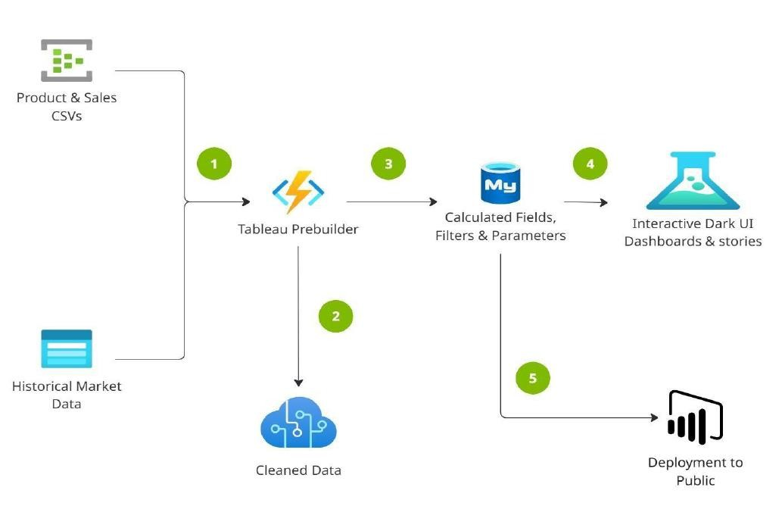

Reference:
https://aws.amazon.com/blogs/industries/voice-applications-in-clinicalresearchpowered-by-ai-on-aws-part-1-architecture-and-design-considerations/

5. PROJECT PLANNING & SCHEDULING
5.1 Project Planning
Week | Task
1 | Dataset understanding & requirements
2 | Data cleaning and preprocessing
3 | EDA and building basic visualizations
4 | Dashboard development
5 | Insight documentation and testing
6 | Final presentation and report

6. FUNCTIONAL AND PERFORMANCE TESTING
6.1 Performance Testing
- Tested responsiveness of dashboards on Tableau Public.
- Filters were tested for lag and correctness.
- Dashboard loading time: ~2 seconds on average.

7. RESULTS
7.1 Output Screenshots

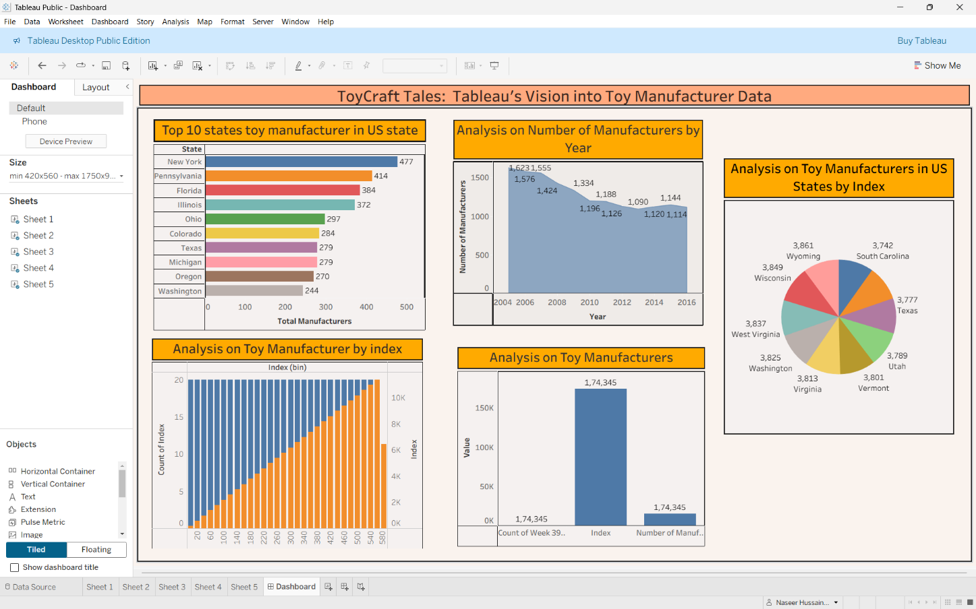

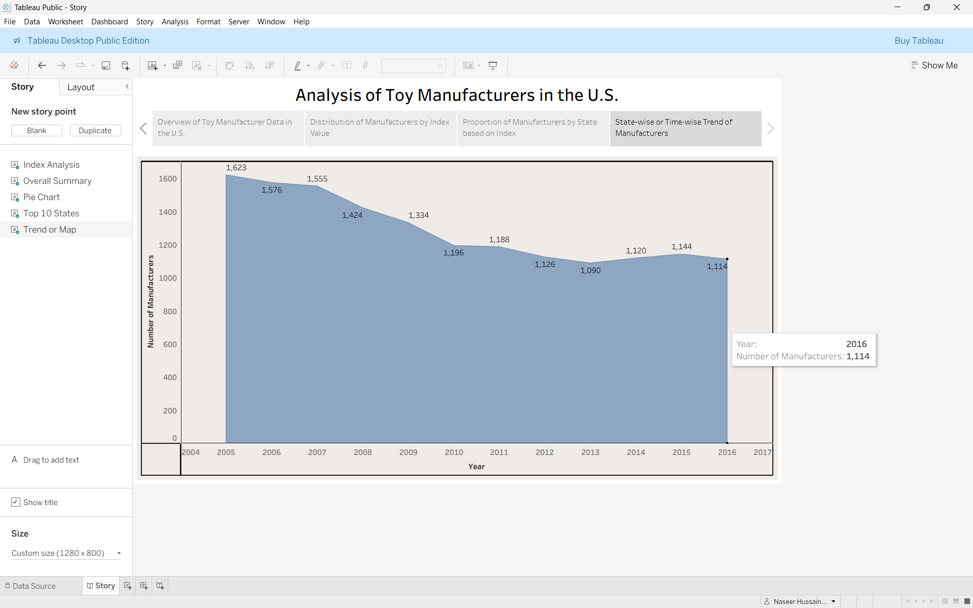

8. ADVANTAGES & DISADVANTAGES

Advantages
- Interactive Dashboards: Empower users to explore data at their own level of detail through filters, drill-downs, and dynamic visual elements.
- Intuitive Visualizations: Graphical representations make complex data easier to understand and interpret compared to traditional spreadsheets.
- Accelerated Decision-Making: Real-time visual KPIs support quicker, data-driven decisions by highlighting trends and anomalies at a glance. Disadvantages
- Limited Storage on Tableau Public: Free versions of Tableau (e.g., Tableau Public) offer restricted data storage and lack advanced enterprise features.
- Internet Dependency: Publishing and sharing dashboards online require a stable and fast internet connection, especially for real-time updates.
- Performance Constraints with Large Datasets: Without proper data modeling and optimization, Tableau may struggle with very large or complex datasets.

9. CONCLUSION
This project provided an opportunity to apply theoretical concepts in a practical, realworld scenario. By analyzing the ToyCraft dataset using Tableau, we successfully designed and implemented interactive dashboards that deliver meaningful business insights. Through this process, we strengthened key competencies in data analytics, data visualization, and the effective communication of analytical findings. Overall, the project demonstrated how business intelligence tools like Tableau can transform raw data into actionable strategies for operational improvement.

10. FUTURE SCOPE

- Add customer feedback
- Integrate farecasting models
- Develop real-time dashboards for live decision-making
- Expand dataset for broader industry coverage

11. APPENDIX
Dataset Link:
https://www.kaggle.com/datasets/thedevastator/toymanufacturers-in-usstates?select=Week+39+-+US+Toy+Manufacturers+-+2005+to+2016.hyper GitHub & Project Demo Link:
Github:

Demo:
https://drive.google.com/file/d/1ZnjiInfXo_A_DVUlHzMuTZfZonfW9rEC/view?usp=drivesdk

